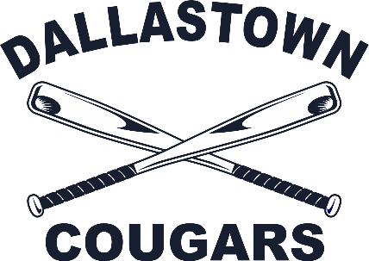 | DALLASTOWN COUGAR LITTLE LEAGUE  TEAM SPONSORSHIP APPLICATION

Thank for your interest in supporting Dallastown Cougar Little League for the upcoming season! Each year, we solicit partnerships with local businesses in order to help us.

A team sponsorship has the following benefits: sponsor name on team jerseys, sponsor team photo plaque, inclusion in sponsor banners at DCLL’s main fields, acknowledgement in our annual yearbook, and interaction on our DCLL social media platforms.

Team sponsorship cost for 2025 is $300.

Community support is a key component in the success of our organization. Thank you for your consideration!

Sponsor Information:
Company Name, as it should appear on shirts (please print clearly):

__________________________________________________________________________________________________
Team/Division/Player Preference (This is not a guarantee, just a preference, we cannot accommodate all special requests): __________________________________________________
Contact Person: ____________________________________________________________
Address: __________________________________________________________________
City: _________________________________ State ________ Zip ________________
Phone: _________________________________ Email _______________________________________
Website: ____________________________________________________________________________
Authorized Signature: ________________________________________________________________
Please make all checks payable to DCA. Payment is due by February 28, 2025 and may be sent to:
DCA / Attn:
Abbey Anderson
58 Jolo Way York, PA 17403

